 USN/TNM/EIK

Report for assignment: Programming a simulator of a control system in OpenModelica

Course: FM1220-1 Automatic Control

Date: 15.10.2021

|  |  |  |  |  |
| --- | --- | --- | --- | --- |
| Family name | Given name and middle name(s) | Student number | Class | Group no. |
| Rådstoga | Lars Rikard | 223786 | IIA-IM | 10 |
|  |  |  |  |  |
|  |  |  |  |  |
|  |  |  |  |  |

# Construct a simulator

Construct a simulator of the wood-chip tank (without a controller system) in OpenModelica. (Include a picture of the model block diagram in the report.)

## Solution

A simulator, seen in Figure 1‑1, for the wood-chip tank without a control system was constructed as part of lecture 4. The simulator is merely an implementation of the mathematical model (1.1) in OpenModelica.

|  |  |
| --- | --- |
|  | (1.1) |

Figure 1‑1 Simulation of the wood chip process without control

# Demonstrate process dynamics

Demonstrate with a simulation that the process dynamics (i.e., the dynamics of the uncontrolled process) is qualitatively "integrator with time-delay". Which process component is due to the integrator, and which is due to the time delay?

## Solution

The height in the tank is due to the integrator, but the integrator is also due to the input flow proportional to the time delayed control signal u. This is displayed in Figure 2‑1 where the red line represents the level that is at first only affected by the integrator due to the outflow represented by the blue line. But is at time = 251s also affected by the time delayed inflow represented by the green line, resulting in a net change of level equal to zero. A control signal u = 50 is required for this result.

Figure 2‑1 Integrator with time delay

# Enhance the simulator with PI

Enhance the process simulator from Task 1 with a PI level controller. (Include a picture of the model block diagram in the report.) The level controller manipulates the control signal (u) in unit of %, and the controller receives hm as the level measurement signal. The level setpoint is 10 m.

## Solution

The enhanced controller can be seen in Figure 3‑1.

Figure 3‑1 Simulator with PI controller.

# Tune the PI with relaxed Ziegler-Nichols

Tune the PI controller using the Relaxed Ziegler-Nichols method. Verify with a simulation that the control system has ok stability with the tuned PI controller.

## Solution

### Part 1

The initial value for the height integrator is set to 10m, and the reference for the controller is initially set to 5 and increased to 10 after 100 seconds. Table 4‑1 shows the PID controller values.

Table 4‑1 Setup values for the PID

|  |  |  |  |
| --- | --- | --- | --- |
|  | Kp | Ti | Td |
| Figure 4‑1 | 25.0 | 99999.0 | 0 |
| Figure 4‑2 | 24.3 | 99999.0 | 0 |

Figure 4‑1 Observed unstability for the control loop at Kp = 25

Figure 4‑2 Observed marginal stability for the control loop at Kp = 24.3

### Part 2

Using the excel sheet in Table 4‑2 the Ziegler-Nichols control parameters are calculated for P, PI and PID control as well as the PI parameters from the relaxed Ziegler-Nichols method.

Simulating in PI mode with the original ZN parameters give decent stability as seen in figure Figure 4‑3. Comparing to the relaxed ZN parameters in **Error! Reference source not found.** we can see that the relaxed method is relaxed indeed as it has less of an overshoot compared to the regular. Though on the other hand the original method has less of an initial undershoot.

Table 4‑2 Control parameters using Ziegler-Nichols



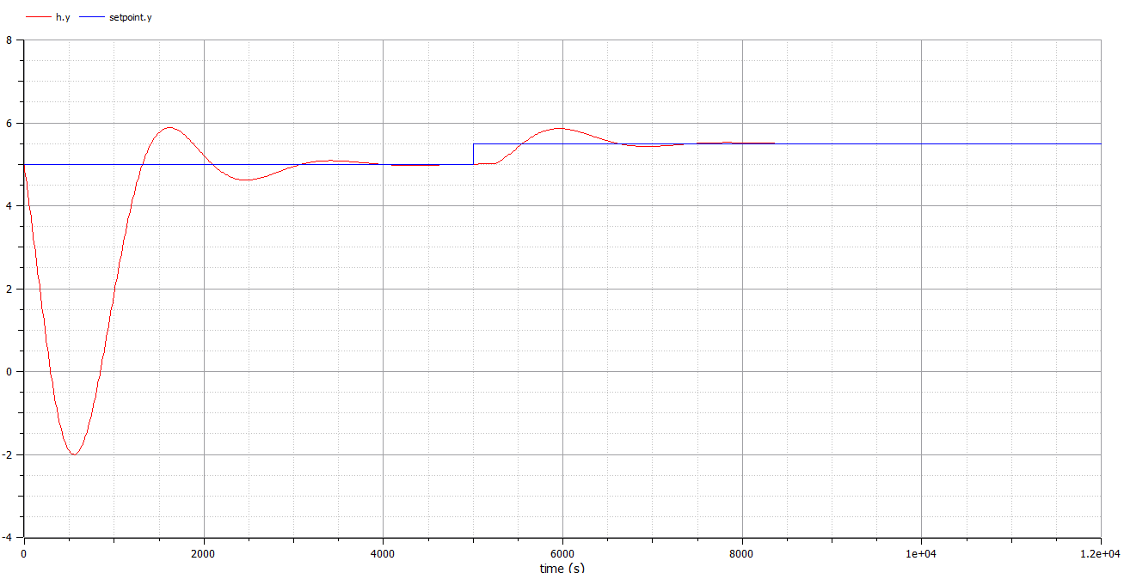

Figure 4‑3 Simulation with Ziegler-Nichols tuned PI controlled, setpoint jump from 5m to 5.5m at time 5000s

Figure 4‑4 Simulation with Relaxed ZN and a jump in setpoint from 5.0m to 5.5m at time 5000s

# Find maximum control error

Assume that the process disturbance (wood chip outflow) changes as step from 1500 to 2000 kg/min. Find from a simulation what is the maximum control error due to this disturbance change. Also find from a simulation what is the steady state control error.

## Solution

It looks like the maximum control error due to the disturbance is about 6.98 meters as shown in Figure 5‑1. Though the steady state error seems to converge to 0 as seen in Figure 5‑2.

Figure 5‑1 Error after output flow disturbance change.

Figure ‑ steady state error.

# Replace the PI controller with P

As in Task 5, but now use a P controller (with the same gain as in the PI control). Which controller do you recommend here - P control or PI controller?

## Solution

For the P controller the error can never be driven to zero and thus the PI controller would be highly recommended here. This can be seen in the simulation shown in Figure 6‑1.

Figure 6‑1 Steady state error with P controller